THEORY QUESTIONS
1.
(a)

In an experiment, four nails 1, 2, 3 and 4 are fixed with candle wax onto a metal bar and one end of bar is heated by means of boiling water as shown in the diagram below.
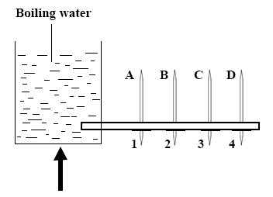
A, B, C and D are thermometers inserted in holes along the bar to measure the temperatures at the various points.
(i)

What is the temperature of the boiling water?
(ii)

State the observations that will be made about nails 1, 2, 3 and 4.
(iii)

State the observations that will be made about the temperature recorded by thermometers A, B, C and D.
(iv)

What mode of heat transfer is demonstrated in the experiment?
(v)

State one effect of heat that is associated with the experiment.
(vi)

State the aim of the experiment.
(b)

In an experiment, a student took three iron nails and cleaned their surfaces dry and placed them in three separate test tubes in set-ups A, B and C as shown in the diagram. After three days the nail in set-up A was found to have rusted while the nails in set-ups B and C did not.
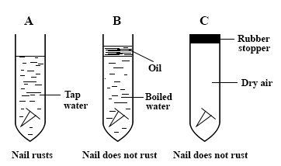
Answer the following questions:
(i)

Why was the water in set-up B boiled?
(ii)

Explain the function of the oil on top of the water in set-up B.
(iii)

State the purpose of the rubber stopper in set-up C.
(iv)

Why did the nail in set-up A rust?
(v)

Suggest an aim for the experiment.
(vi)

From the experiment, explain why oil or grease is applied on the surface of a metal to prevent rusting.
(c)

In an experiment, the following activities were carried out on two green leaves A and B.
Leaf A was from a plant placed in the sunlight for sometime while leaf B was from a plant placed in a dark cupboard for 24 hours.
Activity
I.

Leaves dipped in boiling water for 1 minute
II.

Leaves dipped in warm alcohol
III.

Leaves washed in cold water
IV.

Leaves dipped into iodine solution
After dipping the iodine solution, it was observed that leaf A changed colour while leaf B did not change colour.
Answer the following questions:
(i)

Explain why each of the activities I, II, III and IV was carried out.
(ii)

State the colour change of leaf A.
(iii)

Explain why leaf A changed colour but leaf B did not.
(iv)

Suggest an aim for the experiment.

2.
(a)

Explain each of the following observations in nature:
(i)

In the depths of the ocean where it is always dark, there are no green plants.
(ii)

On an island where there are no insects and birds, the pawpaw plant produces only flowers but no fruits
(b)

Describe how soil is formed.
(c)

(i)

State the laws of reflection
(ii)

Draw a labelled diagram to show the reflection of light on a plane mirror

3.
(a)

A child is found not to be able to see at night
(i)

What deficiency disease may the child be suffering from?
(ii)

What food nutrient is the child lacking?
(iii)

List two sources of food substances that can provide the nutrient the child lacks.
(b)

(i)

What is an atom?
(ii)

Name the components of an atom which determines each of the following quantities.
(α)

mass of an atom
(β)

charge of an atom
(iii)

Why is an atom electrically neutral?
(c)

(i)

What is friction?
(ii)

Give two bad effects of friction.
(iii)

Give two situations where friction is an advantage.

4.
(a)

(i)

Explain heredity
(ii)

Give two examples of heredity characters.
(b)

Explain whether each of the following processes is a chemical change or a physical change:
(i)

Rusting;
(ii)

Burning;
(iii)

Filtration;
(iv)

Expansion of copper.
(c)

(i)

What is a simple machine?
(ii)

Name two types of simple machines.
(iii)

Explain why the efficiency of a machine cannot be equal to 100%.

5.
(a)

Study the organisms listed below:
Earthworm;
Sheep;
Cassava plant;
Grasshopper;
Man;
Hen.
Draw a food chain using four of the organisms
(b)

(i)

Name four types of forces apart from friction.
(ii)

Give three effects of a force.
(c)

A certain pupil in a classroom can see clearly on the blackboard only when he sits at the front.
(i)

State the eye defect the child is suffering from.
(ii)

Explain why the child is unable to see when he is far from the blackboard.
(iii)

How can the defect be corrected?

